|  |  |
| --- | --- |
| *school-learn-study-hat-graduate-512.png* | ***Study*** |

**Part A:**

1. Learn how to print without moving to a new line

Each time we call print(...) to print out something, python will automatically move to a new line, for example, the following snippet:

print("Hello")

print(",my name")

print("is B-max")

will result:

Hello

,my name

is B-max

Your task: Try to search and learn how to print without moving to new line:

print("Hello", ...)

print(",my name", ...)

print("is B-max", ...)

# "..." is the piece of code you would add

so that the result would be

Hello,my name is B-max

**Part B:**

Read Chapter 5, section 5.1, 5.3, 5.5, 5.6, 5.7 and 5.10 of “How to Think Like a Computer Scientist: Learning with Python 3”:

<http://www.ict.ru.ac.za/Resources/cspw/thinkcspy3/thinkcspy3.pdf>

And then answer the following questions:

1. What is Boolean? Write down 3 different expression that results a Boolean type (i.e. 5 == 6)
2. What is a flow chart? Draw flow chart for the following code snippet: (you can draw on a paper, take a picture of it)

if name == “Quan":

print(“Hand some")

elif name == “Tung":

even\_more\_handsome = True

elif name == “Don":

print(“Hi Don”)

else:

webbrowser.open(“<https://www.youtube.com/watch?v=04854XqcfCY>”)

1. What is nested conditionals? Write a piece of code that uses nested conditionals

|  |  |
| --- | --- |
| *http://www.bestappsforkids.com/wp-content/uploads/2012/04/save-turtle.png* | ***Turtle exercises*** |

Using turtle to draw the following shapes:

|  |  |
| --- | --- |
| Screen Shot 2015-12-25 at 04.41.55.png | 2. A dash |
|  |  |

|  |  |
| --- | --- |
| *6iporAnbT.jpg* | ***Serious exercises*** |

1. Write a program that asks user their height (cm) and weight (kg), and then calculate their BMI (Body Mass Index):

**BMI = mass (kg) / (height(m) x height(m) )**

Note: you must do the conversion from cm to m before calculation

Then based on the BMI, tell them that they are:

* Severely underweight if BMI < 16
* Underweight if BMI is between 16 and 18.5
* Normal if BMI is between 18.5 and 25
* Overweight if BMI is between 25 and 30
* Obese if BMI is more than 30

1. Write a program that
   1. Asks users enter a number and then calculates factorial of n: (1 \* 2 \* 3 \*... \* n)
   2. Asks users enter a number and then calculates the harmonic number (1/1 + 1/2 + 1/3 + 1/4 … + 1/n)
2. Print out the following patterns
   * 1. 20 stars



* + 1. n stars, n is from user’s input

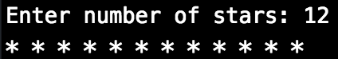

* + 1. 10 stars and 10 x’s, consecutively,:



* + 1. n stars and n x’s, consecutively, n is from user’s input:

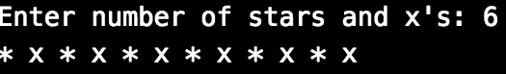

* + 1. [Optional] n stars and x’s **in total**, consecutively, n is from user’s input:

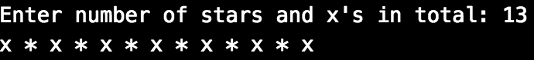

another user case:

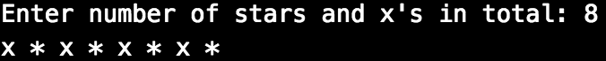

|  |  |
| --- | --- |
| system_config_boot.png | ***Tools preparation*** |

Watch the homework submission tutorial